Graphic Organizers in Microsoft Word
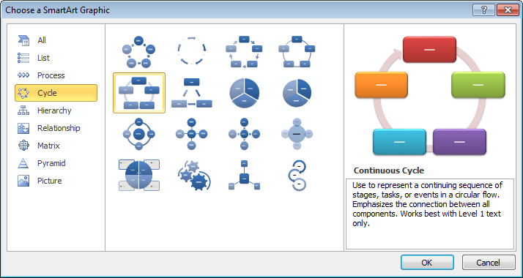
Word’s SmartArt gallery provides dozens of graphic organizers. To access them go to the Insert tab on the ribbon and click SmartArt.
Once you’ve chosen the graphic organizer you wish to use, you can enter text directly onto the shapes or in outline format in the window that appears beside the SmartArt. This window is hidden when you are not editing the SmartArt.
This tab opens and closes the outline window.
Unneeded shapes can be selected and deleted. Additional shapes can be added by just pressing Enter in the outline window to add another bullet.
The entire graphic organizer can be moved and resized using the corners and the four-dot groupings on each side.
Fill, border, and line colors and effects can be changed on the SmartArt Tools ribbon once the object is selected.

Fillable Forms in Microsoft Word
Word’s document protection features allow you to create files that will restrict users’ data entry to the areas you choose.

Steps to Create a Fillable Form
- Open the document you want to convert to a form.
- Go to the Review tab on the ribbon and click Restrict Editing

- Check the box under 2. Editing restrictions and select No changes (Read only) from the drop-down list. Once enforced this will not allow any changes to the document.
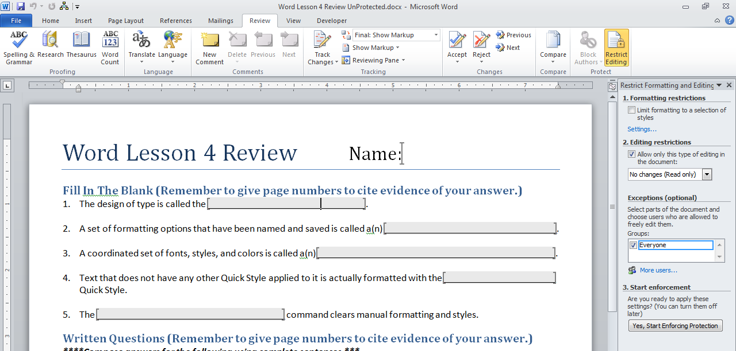
- Select areas where you want to allow editing and check the box beside Everyone. The unrestricted areas are shaded and have square brackets around them.

- Click the Yes, Start Enforcing Protection button.
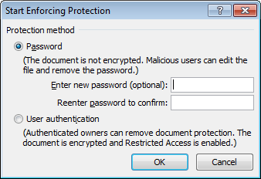
- If you enter a password, Word will require the password before the restricted editing
can be disabled. If you don’t want to use a password, just click OK without entering one.

